**Week 9**

**Penetration Testing Report**

**Introduction**

This report document hereby describes the proceedings and results of a Black Box security assessment conducted against the **Week 9 Labs**. The report hereby lists the findings and corresponding best practice mitigation actions and recommendations.

**1. Objective**

The objective of the assessment was to uncover vulnerabilities in the **Week 9 Labs** and provide a final security assessment report comprising vulnerabilities, remediation strategy and recommendation guidelines to help mitigate the identified vulnerabilities and risks during the activity.

**2. Scope**

This section defines the scope and boundaries of the project.

| **Application Name** | **SQL Injection** |
| --- | --- |

**3. Summary**

Outlined is a Black Box Application Security assessment for the **Week 9 Labs**.

**Total number of Sub-labs: 12 Sub-labs**

| **High** | **Medium** | **Low** |
| --- | --- | --- |
| **4** | **4** | **4** |

**High - Number of Sub-labs with hard difficulty level**

**Medium - Number of Sub-labs with Medium difficulty level**

**Low - Number of Sub-labs with Easy difficulty level**

# 1. SQL Injection

# 1.1. Strings & Errors Part 1!

| **Reference** | **Risk Rating** |
| --- | --- |
| Strings & Errors Part 1! | **Low / Medium / High** |
| **Tools Used** | |
| Manual injection | |
| **Vulnerability Description** | |
| SQL Injection allows an attacker to view data that attackers are normally not able to retrieve.  Data can be information about users their credentials, personal details etc.  This is blindbased sqli. | |
| **How It Was Discovered** | |
| Manual Analysis | |
| **Vulnerable URLs** | |
| <https://www.bugbountyhunter.org/internship_labs/HTML/sqli_lab/lab_1/lab_1.php> | |
| **Consequences of not Fixing the Issue** | |
| If poor SQL commands are used to check user names and passwords, it may be  possible to connect to a system as another user with no previous knowledge of the password. | |
| **Suggested Countermeasures** | |
| Give some Suggestions to stand against this vulnerability | |
| **References** | |
| <https://portswigger.net/web-security/sql-injection> | |

# 

# Proof of Concept

**Query:**

Email:" or ""="

Password=" or ""="

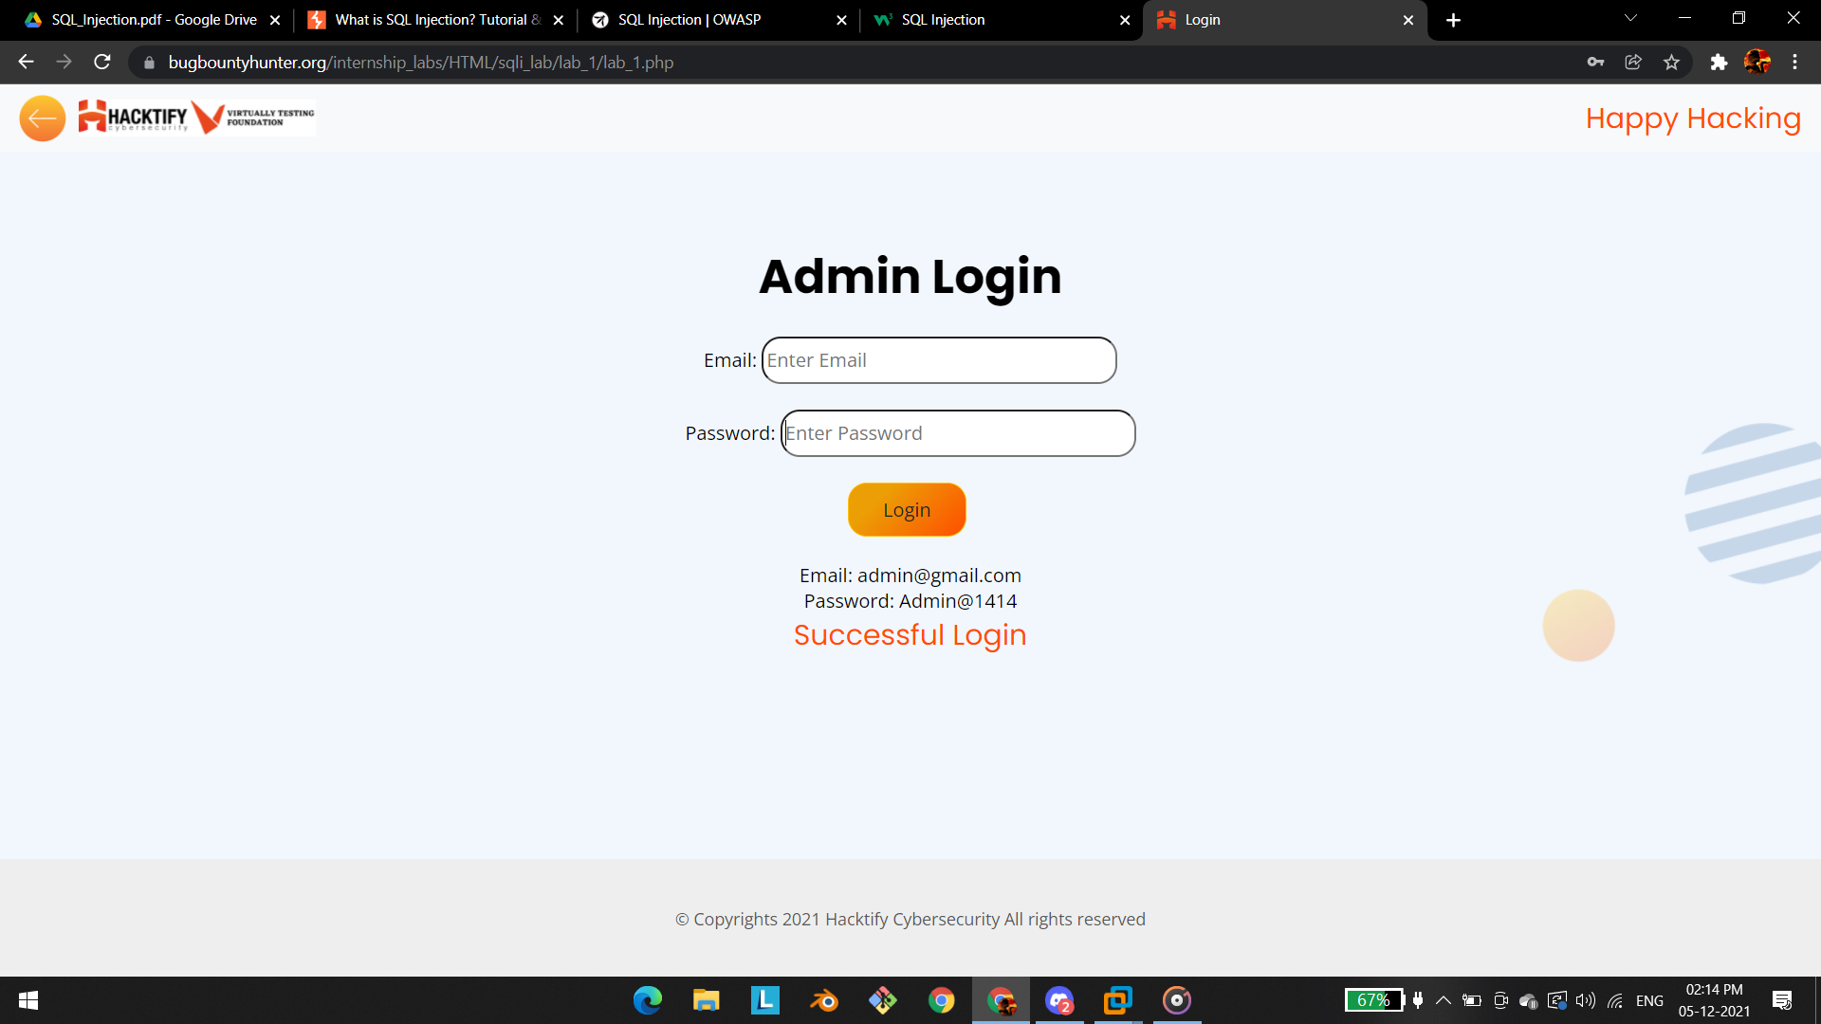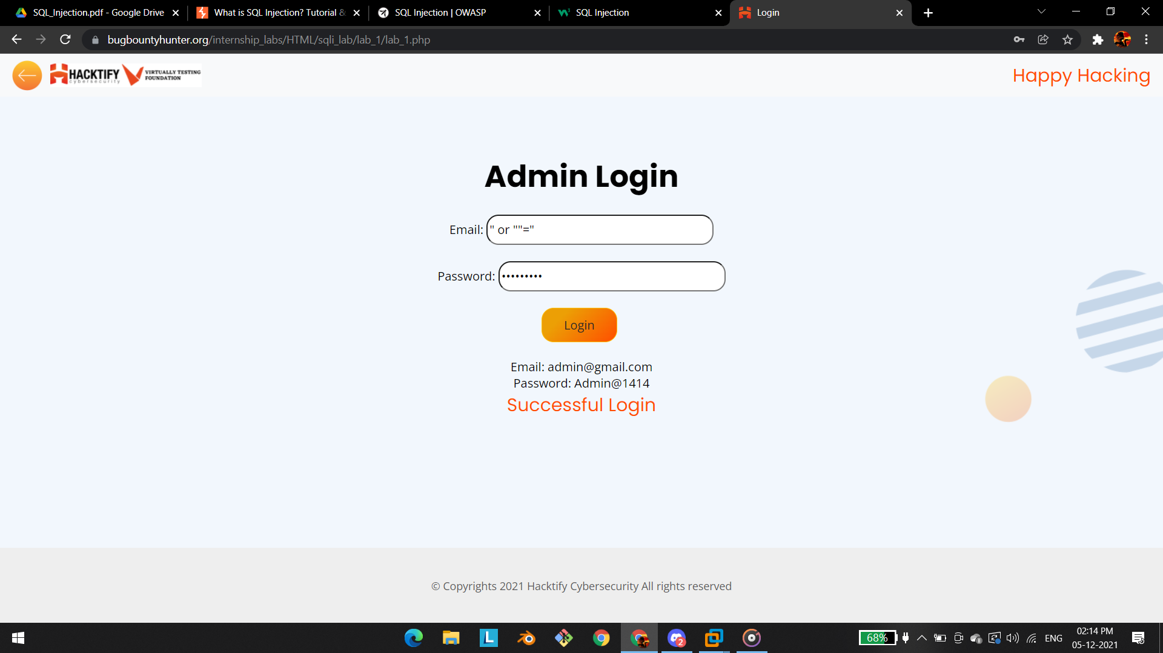

# 1.2. Strings & Errors Part 2!

| **Reference** | **Risk Rating** |
| --- | --- |
| Strings & Errors Part 2! | **Low / Medium / High** |
| **Tools Used** | |
| Manual injection | |
| **Vulnerability Description** | |
| SQL Injection allows an attacker to view data that attackers are normally not able to retrieve.  Data can be information about users their credentials, personal details etc.  the malicious got executed in url field with the parameter called **id.** | |
| **How It Was Discovered** | |
| Manual Analysis | |
| **Vulnerable URLs** | |
| <https://www.bugbountyhunter.org/internship_labs/HTML/sqli_lab/lab_2/lab_2.php> | |
| **Consequences of not Fixing the Issue** | |
| What will be the consequences if the vulnerability is not patched? | |
| **Suggested Countermeasures** | |
| Give some Suggestions to stand against this vulnerability | |
| **References** | |
| <https://owasp.org/www-community/attacks/SQL_Injection> | |

# Proof of Concept

**Query:**

**query->' OR 'x'='x**

**link:**<https://www.bugbountyhunter.org/internship_labs/HTML/sqli_lab/lab_2/lab_2.php?id=%27%20OR%20%27x%27=%27x>

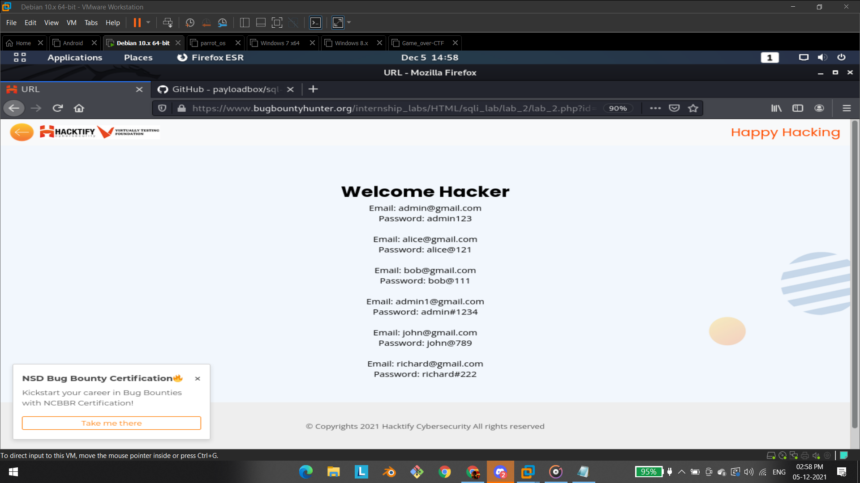

# 

# 

# 

# 1.3. Strings & Errors Part 3!

| **Reference** | **Risk Rating** |
| --- | --- |
| Strings & Errors Part 3! | **Low / Medium / High** |
| **Tools Used** | |
| Manual injection | |
| **Vulnerability Description** | |
| SQL Injection allows an attacker to view data that attackers are normally not able to retrieve.  Data can be information about users their credentials, personal details etc.  the malicious got executed in url field with the parameter called **id** and the attacker can able to retrieve the username and passwords of all the username and password that are stored in the database | |
| **How It Was Discovered** | |
| Manual Analysis | |
| **Vulnerable URLs** | |
| <https://www.bugbountyhunter.org/internship_labs/HTML/sqli_lab/lab_3/lab_3.php> | |
| **Consequences of not Fixing the Issue** | |
| What will be the consequences if the vulnerability is not patched? | |
| **Suggested Countermeasures** | |
| Give some Suggestions to stand against this vulnerability | |
| **References** | |
| <https://portswigger.net/web-security/sql-injection> | |

# 

# Proof of Concept

**Query:**

Query:" or ""="

**link:**[https://www.bugbountyhunter.org/internship_labs/HTML/sqli_lab/lab_3/lab_3.php?id=" or ""="](https://www.bugbountyhunter.org/internship_labs/HTML/sqli_lab/lab_3/lab_3.php?id=)

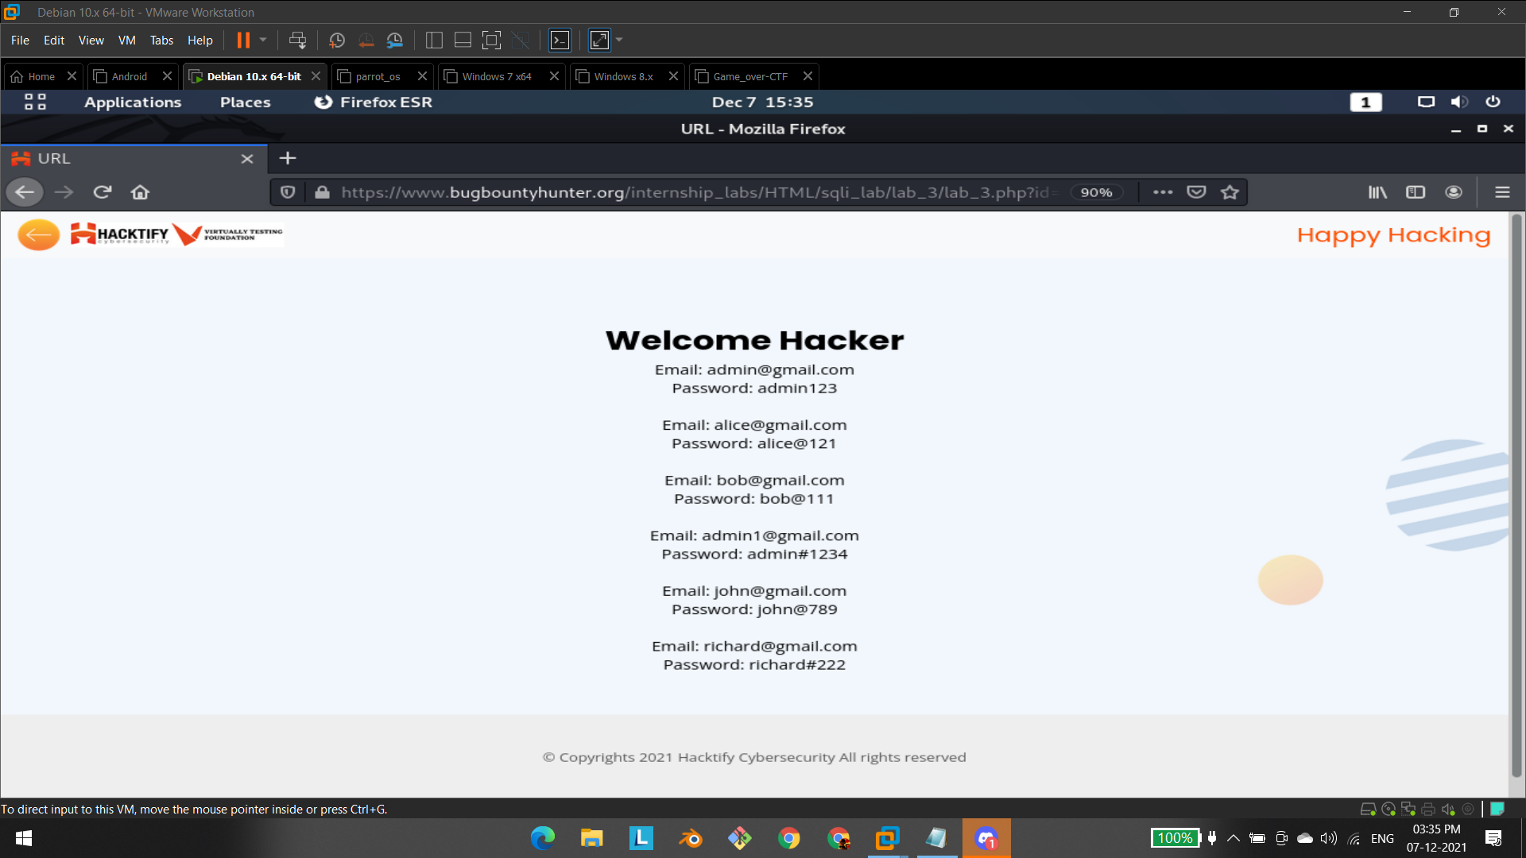

# 1.4. Let's Trick 'Em!

| **Reference** | **Risk Rating** |
| --- | --- |
| Let's Trick 'Em! | **Low / Medium / High** |
| **Tools Used** | |
| Tools that you have used to find the vulnerability. | |
| **Vulnerability Description** | |
| About the vulnerability and its working | |
| **How It Was Discovered** | |
| Automated Tools / Manual Analysis | |
| **Vulnerable URLs** | |
| URLs of the vulnerable pages in the lab | |
| **Consequences of not Fixing the Issue** | |
| What will be the consequences if the vulnerability is not patched? | |
| **Suggested Countermeasures** | |
| Give some Suggestions to stand against this vulnerability | |
| **References** | |
| URLs to the sources used to know more about this vulnerability | |

# 

# Proof of Concept

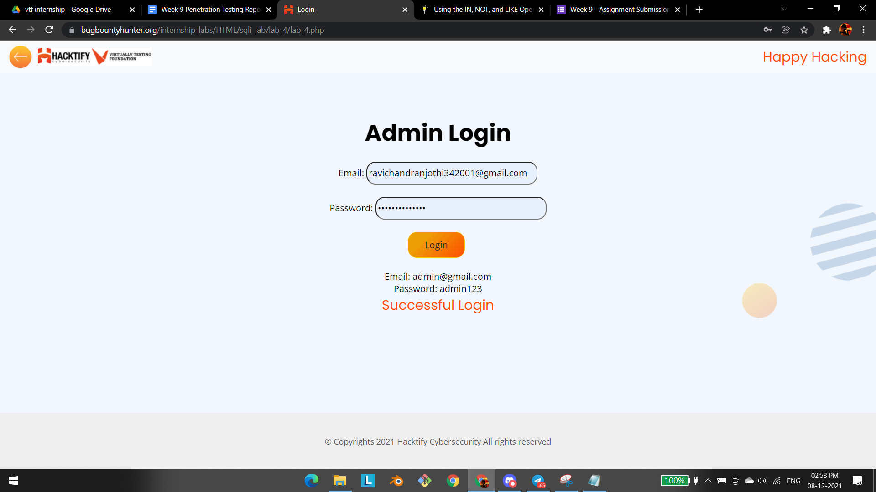

# 

# 

# 1.5. Booleans And Blind!

| **Reference** | **Risk Rating** |
| --- | --- |
| Booleans And Blind! | **Low / Medium / High** |
| **Tools Used** | |
| Tools that you have used to find the vulnerability. | |
| **Vulnerability Description** | |
| About the vulnerability and its working | |
| **How It Was Discovered** | |
| Automated Tools / Manual Analysis | |
| **Vulnerable URLs** | |
| URLs of the vulnerable pages in the lab | |
| **Consequences of not Fixing the Issue** | |
| What will be the consequences if the vulnerability is not patched? | |
| **Suggested Countermeasures** | |
| Give some Suggestions to stand against this vulnerability | |
| **References** | |
| URLs to the sources used to know more about this vulnerability | |

# 

# Proof of Concept

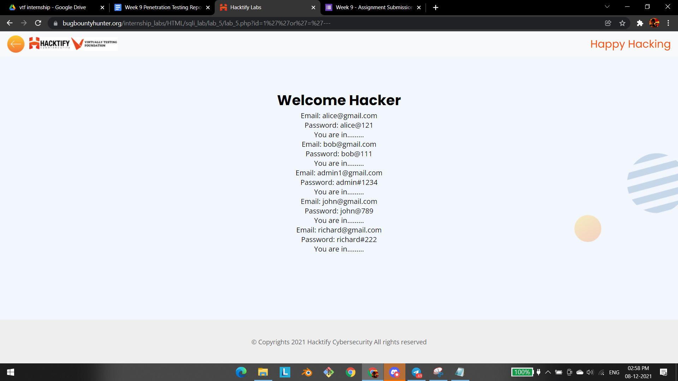

# 1.6. Error Based : Tricked

| **Reference** | **Risk Rating** |
| --- | --- |
| Error Based : Tricked | **Low / Medium / High** |
| **Tools Used** | |
| Tools that you have used to find the vulnerability. | |
| **Vulnerability Description** | |
| About the vulnerability and its working | |
| **How It Was Discovered** | |
| Automated Tools / Manual Analysis | |
| **Vulnerable URLs** | |
| URLs of the vulnerable pages in the lab | |
| **Consequences of not Fixing the Issue** | |
| What will be the consequences if the vulnerability is not patched? | |
| **Suggested Countermeasures** | |
| Give some Suggestions to stand against this vulnerability | |
| **References** | |
| URLs to the sources used to know more about this vulnerability | |

# 

# Proof of Concept

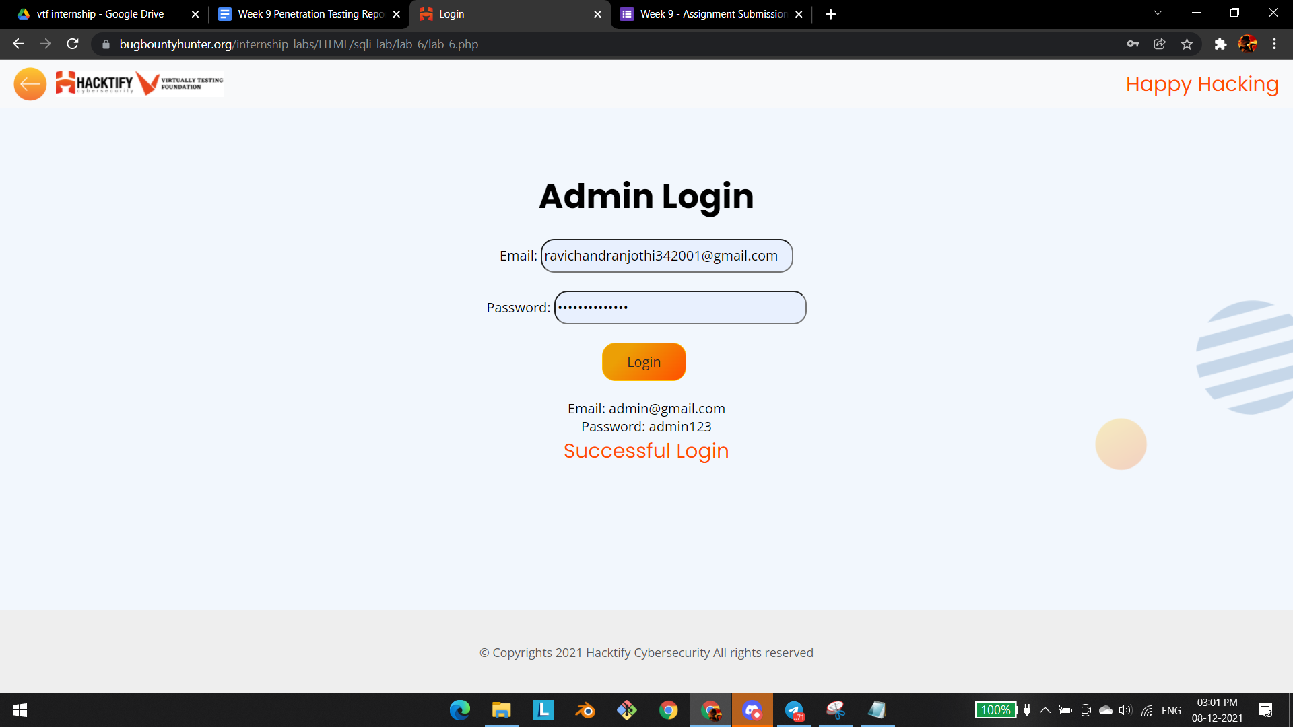

# 1.7. Errors And Post!

| **Reference** | **Risk Rating** |
| --- | --- |
| Errors And Post! | **Low / Medium / High** |
| **Tools Used** | |
| Tools that you have used to find the vulnerability. | |
| **Vulnerability Description** | |
| About the vulnerability and its working | |
| **How It Was Discovered** | |
| Automated Tools / Manual Analysis | |
| **Vulnerable URLs** | |
| URLs of the vulnerable pages in the lab | |
| **Consequences of not Fixing the Issue** | |
| What will be the consequences if the vulnerability is not patched? | |
| **Suggested Countermeasures** | |
| Give some Suggestions to stand against this vulnerability | |
| **References** | |
| URLs to the sources used to know more about this vulnerability | |

# 

# Proof of Concept

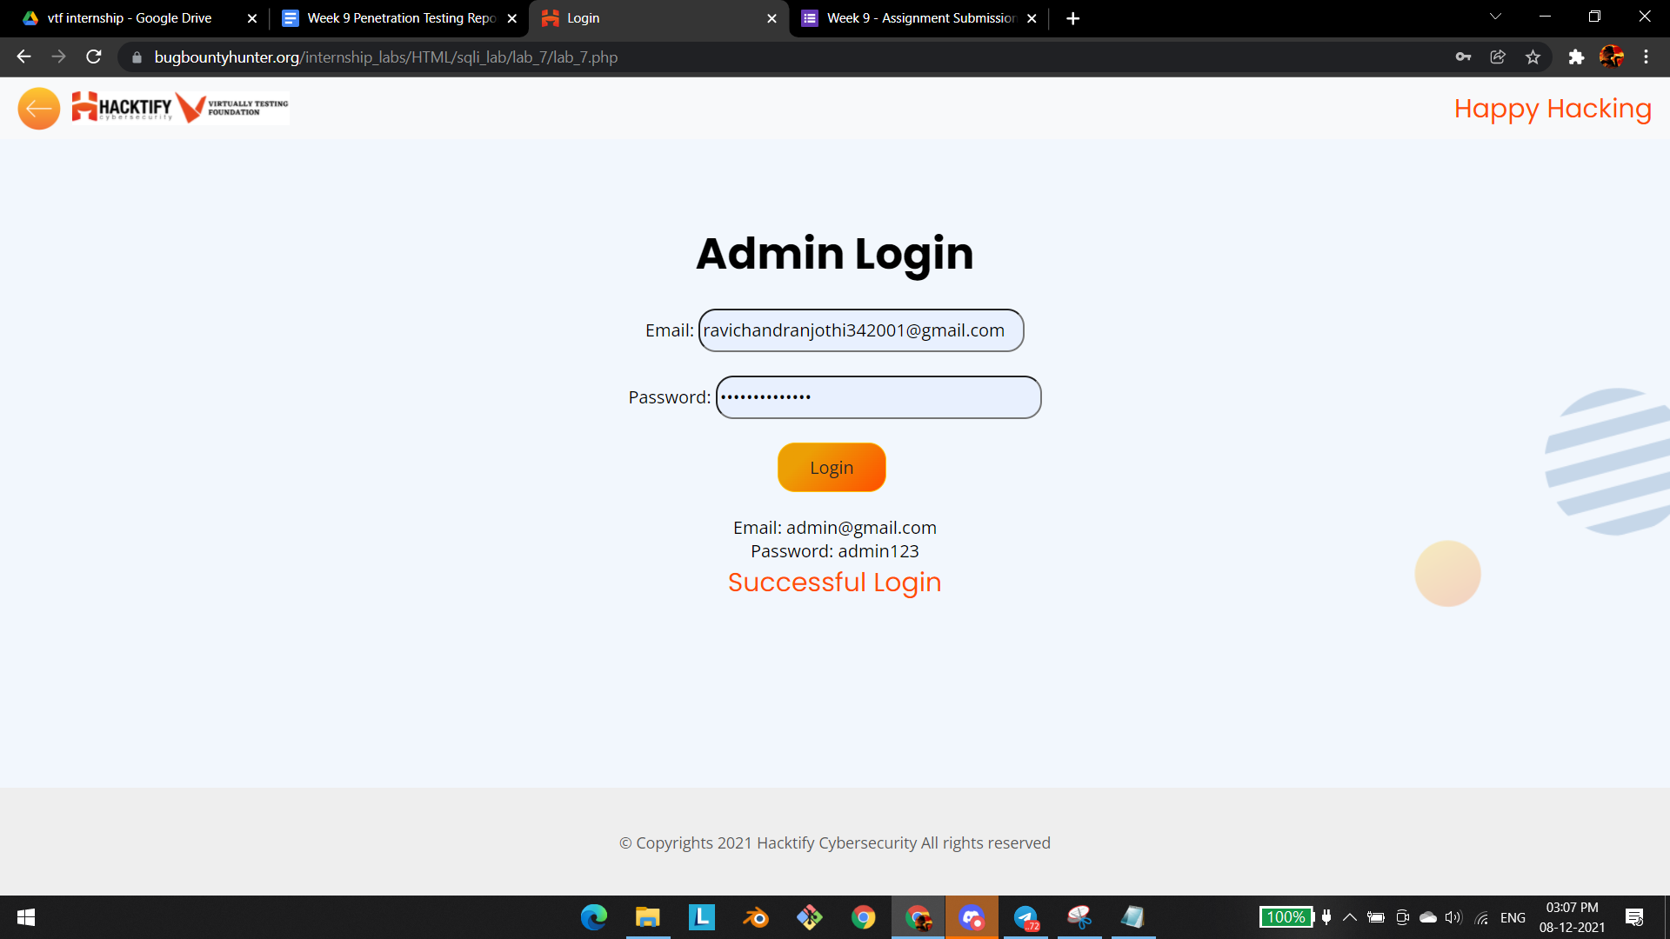

# 

# 

# 1.8. User Agents Lead Us!

| **Reference** | **Risk Rating** |
| --- | --- |
| User Agents Lead Us! | **Low / Medium / High** |
| **Tools Used** | |
| Tools that you have used to find the vulnerability. | |
| **Vulnerability Description** | |
| About the vulnerability and its working | |
| **How It Was Discovered** | |
| Automated Tools / Manual Analysis | |
| **Vulnerable URLs** | |
| URLs of the vulnerable pages in the lab | |
| **Consequences of not Fixing the Issue** | |
| What will be the consequences if the vulnerability is not patched? | |
| **Suggested Countermeasures** | |
| Give some Suggestions to stand against this vulnerability | |
| **References** | |
| URLs to the sources used to know more about this vulnerability | |

# 

# Proof of Concept

# 1.9. Referer Lead Us!

| **Reference** | **Risk Rating** |
| --- | --- |
| Referer Lead Us! | **Low / Medium / High** |
| **Tools Used** | |
| Tools that you have used to find the vulnerability. | |
| **Vulnerability Description** | |
| About the vulnerability and its working | |
| **How It Was Discovered** | |
| Automated Tools / Manual Analysis | |
| **Vulnerable URLs** | |
| URLs of the vulnerable pages in the lab | |
| **Consequences of not Fixing the Issue** | |
| What will be the consequences if the vulnerability is not patched? | |
| **Suggested Countermeasures** | |
| Give some Suggestions to stand against this vulnerability | |
| **References** | |
| URLs to the sources used to know more about this vulnerability | |

# 

# Proof of Concept

This section contains the proof of the above vulnerabilities as the screenshot of the vulnerability of the lab

# 1.10. Oh Cookies!

| **Reference** | **Risk Rating** |
| --- | --- |
| Oh Cookies! | **Low / Medium / High** |
| **Tools Used** | |
| Tools that you have used to find the vulnerability. | |
| **Vulnerability Description** | |
| About the vulnerability and its working | |
| **How It Was Discovered** | |
| Automated Tools / Manual Analysis | |
| **Vulnerable URLs** | |
| URLs of the vulnerable pages in the lab | |
| **Consequences of not Fixing the Issue** | |
| What will be the consequences if the vulnerability is not patched? | |
| **Suggested Countermeasures** | |
| Give some Suggestions to stand against this vulnerability | |
| **References** | |
| URLs to the sources used to know more about this vulnerability | |

# 

# Proof of Concept

This section contains the proof of the above vulnerabilities as the screenshot of the vulnerability of the lab

# 1.11. WAF's Are Injected!

| **Reference** | **Risk Rating** |
| --- | --- |
| WAF's Are Injected! | **Low / Medium / High** |
| **Tools Used** | |
| Tools that you have used to find the vulnerability. | |
| **Vulnerability Description** | |
| About the vulnerability and its working | |
| **How It Was Discovered** | |
| Automated Tools / Manual Analysis | |
| **Vulnerable URLs** | |
| URLs of the vulnerable pages in the lab | |
| **Consequences of not Fixing the Issue** | |
| What will be the consequences if the vulnerability is not patched? | |
| **Suggested Countermeasures** | |
| Give some Suggestions to stand against this vulnerability | |
| **References** | |
| URLs to the sources used to know more about this vulnerability | |

# 

# Proof of Concept

This section contains the proof of the above vulnerabilities as the screenshot of the vulnerability of the lab

# 

# 

# 

# 

# 

# 

# 1.12. WAF's Are Injected Part 2!

| **Reference** | **Risk Rating** |
| --- | --- |
| WAF's Are Injected Part 2! | **Low / Medium / High** |
| **Tools Used** | |
| Tools that you have used to find the vulnerability. | |
| **Vulnerability Description** | |
| About the vulnerability and its working | |
| **How It Was Discovered** | |
| Automated Tools / Manual Analysis | |
| **Vulnerable URLs** | |
| URLs of the vulnerable pages in the lab | |
| **Consequences of not Fixing the Issue** | |
| What will be the consequences if the vulnerability is not patched? | |
| **Suggested Countermeasures** | |
| Give some Suggestions to stand against this vulnerability | |
| **References** | |
| URLs to the sources used to know more about this vulnerability | |

# 

# Proof of Concept

This section contains the proof of the above vulnerabilities as the screenshot of the vulnerability of the lab